Electrical/Bio Engineering Case Study – Fear Analysis using GSR Data
Demarce Williams (dsw9740)

ENGR-UH 1000, Fall 2023

STEP 1: Problem Identification and. Statement

The objective of this assignment is to develop a software to find the Fear Index using a set of GSR Data values, and a sequence of filters. The program will calculate the Fear Index based on 10 features extracted from the GSR Data set and return the Fear Index value and GSR-time graphs representing the data.

STEP 2: Gathering of Information and Input and Output Description

The galvanic skin response (GSR) is a measure of skin conductance influenced by the autonomic nervous system's sympathetic branch, regulating sweating. Sympathetic arousal increases sweat gland activity, elevating skin conductance, and vice versa. GSR sensors, like the Grove GSR sensor, measure sweat gland activity, correlating with emotional arousal. The sensor utilizes two electrodes on fingers, converting analogue voltage to digital via an Arduino microcontroller, then transmitting data to a computer as shown in the figure below.

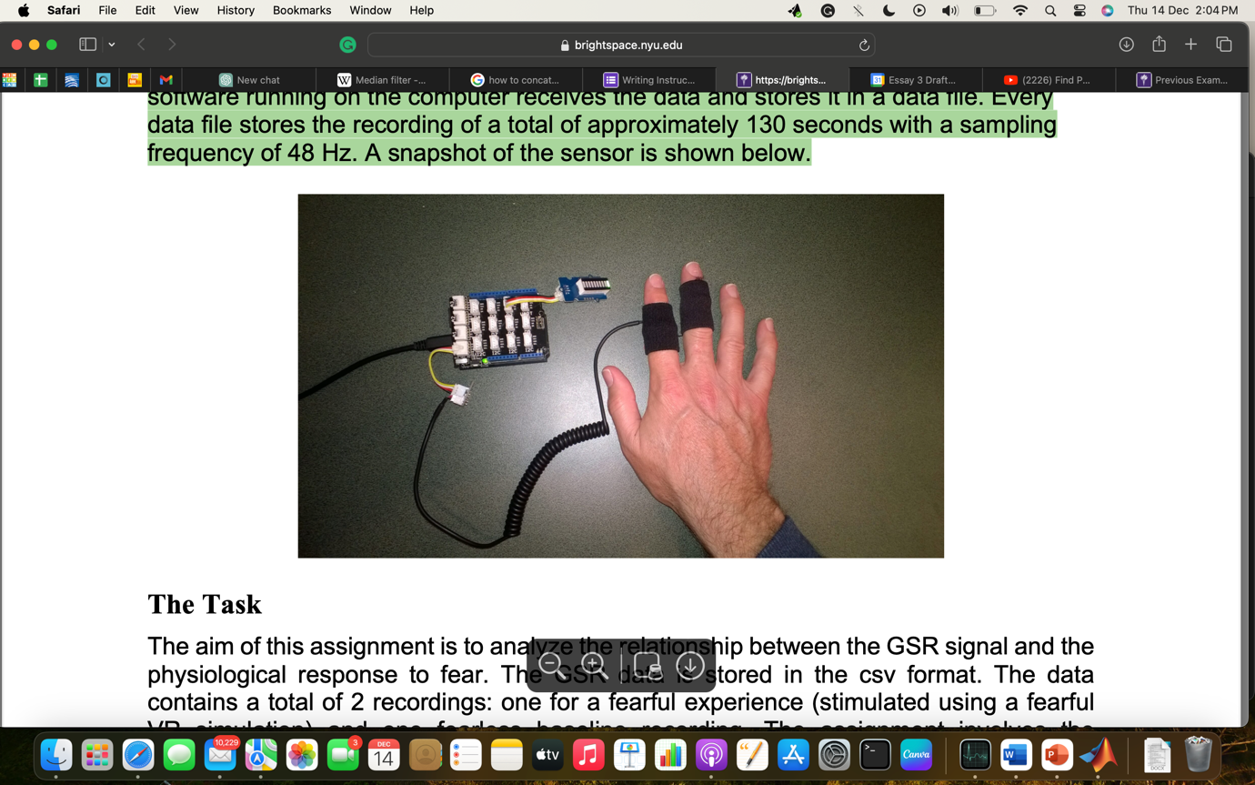

GSR data, measured in micro-Siemens, reflects skin conductance. Beyond emotional arousal monitoring, GSR is used in various fields, including psychology and polygraphs, for lie detection. This assignment involves processing GSR data in MATLAB to detect fear. The data acquisition system records approximately 130 seconds of data at 48 Hz, offering insights into emotional responses.

The fear index value is calculated using the following features:
- Mean of GSR Signal (F1): The average value of the GSR signal over the recording period which indicates the central tendency of the skin conductance responses.

- Variance of GSR Signal (F2): Description: The measure of how much the GSR values deviate from the mean which reflects the overall variability or spread of the skin conductance responses.

- GSR Peak Rise Time Sum (F3): The sum of the rise times for all detected GSR peaks which represents the cumulative time it takes for the skin conductance to rise to its peak level from the preceding trough level.

- GSR Peak Amplitude Sum (F4): The sum of the amplitudes of all detected GSR peaks which indicates the cumulative magnitude of the skin conductance responses.

- GSR Peak Energy Sum (F5): The sum of the energies of all detected GSR peaks, calculated as 1/2 * amplitude * rise time which provides a measure that combines both the amplitude and rise time of the skin conductance responses.

- Amplitude of the Highest Skin Conductance Response (F6): The magnitude of the highest GSR peak in the recording which highlights the intensity of the most prominent skin conductance response.

- Rise Time of the Highest Skin Conductance Response (F7): The time it takes for the GSR signal to rise to its peak for the highest response.

- Number of GSR Peaks (F8): The count of distinct peaks in the GSR signal which indicates the frequency of skin conductance responses during the recording.

- Mean Power of GSR Signal (F9): The average power of the GSR signal, computed as the mean of the squared GSR values.

- GSR Bandwidth (F10): The GSR Bandwidth is a measure of the frequency content of the GSR signal. It is calculated using the formula:
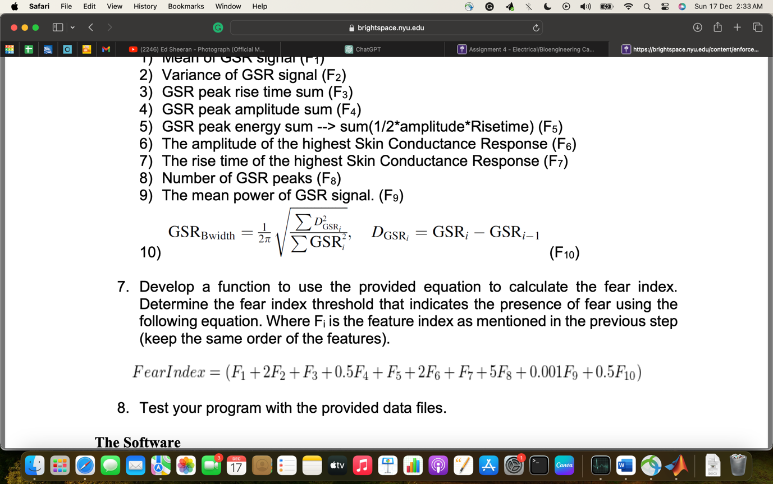
GSR Bandwidth represents the distribution of frequency components in the GSR signal. A higher GSR Bandwidth may suggest a broader range of changes in skin conductance, reflecting varied physiological responses.

The fear index, which indicates the presence of fear, is then calculated using the following equation:
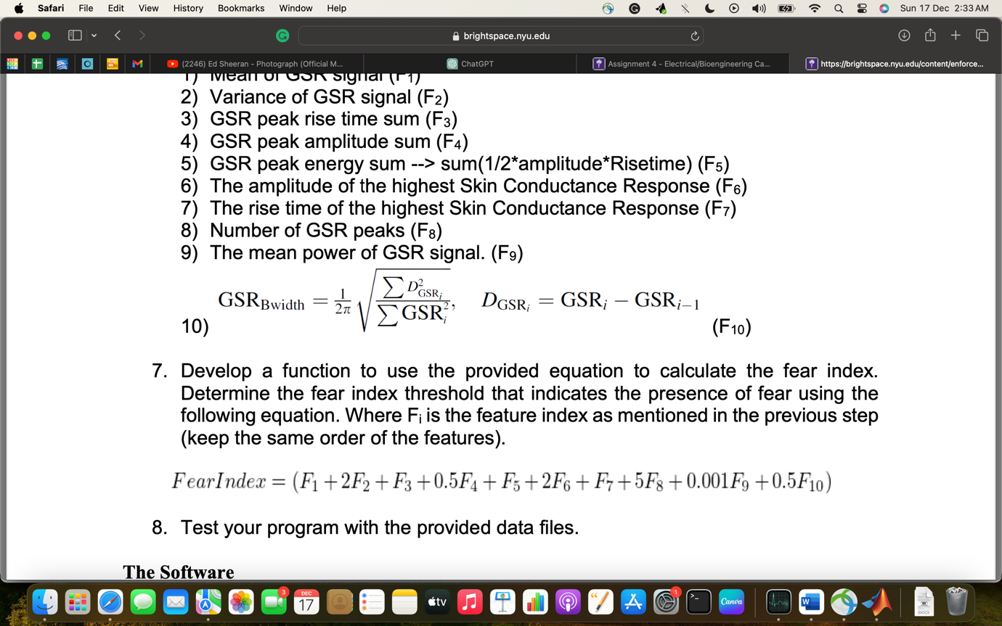
The inputs/outputs may be represented as follows:
The user upon starting the program will be presented with a menu that gives them six options and will be asked to select one of the six options.
Inputs
- GSR Data file, median order, N-point moving average order, passband frequency
Output
- Fear Index, GSR-time graphs

Alternative Block Diagram

GSR Data csv file

Median order
Fear Index
N-point moving average order

GSR-Time Graphs

Passband frequency

STEP 3: Test Cases and Algorithm Design
- Test Cases
The following data set is tested with a 3rd order median filter, 10-point moving average filter, and 20 Hz passband frequency for the lowpass filter.

Test case 1: GSR_FEAR.csv
  - Expectation about Fear Index: Anticipate a heightened fear index result for this dataset.
  - Graphical Representation of Smoothing: The graphs are expected to exhibit consistent smoothness as a result of the applied filter.
  - Graphical Representation of Fluctuations and Separations: The graph should display increased fluctuations and noticeable trough-peak separations.

Test case 2: GSR_Baseline.csv
  - Expectation about Fear Index: Anticipate a low fear index result for this dataset.
  - Graphical Representation of Smoothing: The graphs are expected to exhibit consistent smoothness as a result of the applied filter.
  - Graphical Representation of Fluctuations and Separations: The graph should display reduced fluctuations and negligible trough-peak separations.

- Pseudocode Algorithm

START
Assign GSR Data file with extension to file
Assign 3 to med_order
Assign 10 to n_order
Assign20 to fp
GSRData = CALL loadGSRData with argument: file
Assign return value from CALL nthOrderMedianFilter with arguments: med_order, GSRData to filteredGSRData
Assign return value from CALL lowPassFilter with arguments: fp, filteredGSRData to filteredGSRData
Assign return value from CALL nPointMovingAverageFilter with arguments: n_order, filteredGSRData to filteredGSRData
Assign return value from CALL normaliseData with arguments: filteredGSRData to normalisedGSRData
Assign return value from CALL gsrFeatures with argument normalisedGSRData to F
Assign return value from CALL calculateFearIndex with argument: F to FearIndex
Print newline, “The fear index is:”, FearIndex, newline
END

Function Definitions

Note the following format:

Module Name: Function name
Module Description: Description of the purpose of function
ARGUMENTS: List of function arguments

PROCESS: Function definition goes here.

OUTPUT: State the return value of function, if any.
End Module: Function name, to signify end of function definition.
Each function used will begin on a new page.

Module Name: loadGSRData
Module Description: The following function loads GSR Data values from a file, passed as an argument and returns a matrix containing the data.

ARGUMENTS: data_file
PROCESS:
Open file, data_file, for reading

if file is equal to -1, then
Print “Error! Could not open file!”’ newline
end if

Skip header
Read time and gsr data from file in formats mm:ss:SSS and double, respectively, delimited by a comma and store in data

Assign return value from CALL seconds(data{1}-data{1}(1)) to time

Close file

GSRData = {time, data{2}}
OUTPUT: GSRData
End Module: loadGSRData

Module Name: nthOrderMedianFilter

Module Description: The following function creates a nth order median filter for data set. It accepts two arguments: N-the median order and GSRData-the GSR data 3D cell array and returns a filtered 3D cell array.

ARGUMENTS: N, GSRData

PROCESS:
Assign GSRData to filteredGSRData
for i = 1 to length(GSRData(2)), repeat
Assign return value from CALL zeros(1, N) to subset
Assign 1 to k
for j = -(floor((N-1)/2)) to ceil((N-1)/2), repeat
Assign i + j to index
Assign return value from CALL max(1, min(index, length(GSRData(2))))
Assign GSRData{2}(index) to subset(k)
Increment k by 1
end for
Assign return value from CALL median(subset) to filteredGSRData{2}(i)
end for
Create new figure
Create 2 x 1 subplot
At subplot position 1
Plot GSRData{1} vs GSRData{2}
Set title "GRAPH OF GSR DATA BEFORE MEDIAN FILTRATION"
Set x label "Time (s)"
Set y label "GSR Values (uS)"
At subplot position 1
Plot filteredGSRData{1} vs filteredGSRData{2} in red
Set title "GRAPH OF GSR DATA AFTER MEDIAN FILTRATION"
Set x label "Time (s)"
Set y label "GSR Values (uS)"
Saves current figure as "Med_Filt.jpg"
OUTPUT: filteredGSRData
End Module: nthOrderMedianFilter
Module Name: nPointMovingAverageFilter

Module Description: The following function creates a n-point moving average filter for data set. It accepts two arguments: N-the moving average order and GSRData-the GSR data 3D cell array and returns a filtered 3D cell array.

ARGUMENTS: N, GSRData

PROCESS:
Assign GSRData to filteredGSRData
for i = 1 to length(GSRData(2)), repeat
Assign return value from CALL zeros(1, N) to subset
Assign 1 to k
for j = -(floor((N-1)/2)) to ceil((N-1)/2), repeat
Assign i + j to index
Assign return value from CALL max(1, min(index, length(GSRData(2))))
Assign GSRData{2}(index) to subset(k)
Increment k by 1
end for
Assign return value from CALL mean(subset) to filteredGSRData{2}(i)
end for
Create new figure
Create 2 x 1 subplot
At subplot position 1
Plot GSRData{1} vs GSRData{2}
Set title "GRAPH OF GSR DATA BEFORE N-POINT MOVING AVERAGE FILTRATION"
Set x label "Time (s)"
Set y label "GSR Values (uS)"
At subplot position 1
Plot filteredGSRData{1} vs filteredGSRData{2} in red
Set title "GRAPH OF GSR DATA AFTER N-POINT MOVING AVERAGE FILTRATION"
Set x label "Time (s)"
Set y label "GSR Values (uS)"
Saves current figure as "Moving_Average.jpg"

OUTPUT: filteredGSRData
End Module: nPointMovingAverageFilter

Module Name: lowPassFilter

Module Description: The following function creates a lowpass filter for data set. It accepts two arguments: fp-the passband frequency and GSRData-the GSR data 3D cell array and returns a filtered 3D cell array.

ARGUMENTS: fp, GSRData

PROCESS:
Assign GSRData to filteredGSRData
Assign GSRData to filteredGSRData
Assign return value from CALL diff(GSRData(1)) to timeDifference
Assign 1/fp to meanWindowSize
Assign return value from CALL round(meanWindowSize / median(timeDifference)) to meanWindowPoints
Assign return value from smoothdata(GSRData{2}, 'movmean', meanWindowPoints) to filteredGSRData{2}

Create new figure
Create 2 x 1 subplot
At subplot position 1
Plot GSRData{1} vs GSRData{2}
Set title "GRAPH OF GSR DATA BEFORE LOW PASS FILTRATION"
Set x label "Time (s)"
Set y label "GSR Values (uS)"
At subplot position 1
Plot filteredGSRData{1} vs filteredGSRData{2} in red
Set title "GRAPH OF GSR DATA AFTER LOW PASS FILTRATION"
Set x label "Time (s)"
Set y label "GSR Values (uS)"
Saves current figure as "Med_Filt.jpg"

OUTPUT: filteredGSRData
End Module: lowPassFilter
Module Name: normaliseData

Module Description: The following function creates a lowpass filter for data set. It accepts two arguments: fp-the passband frequency and GSRData-the GSR data 3D cell array and returns a filtered 3D cell array.

ARGUMENTS: GSRData

PROCESS:
Assign GSRData to normalisedData
for i = 1 to length(GSRData(2)), repeat
Assign ((GSRData{2}(i) - min(GSRData{2})) / (max(GSRData{2})-min(GSRData{2})))* 100 to normalisedData{2}(i)
end for
Create new figure
Create 2 x 1 subplot
At subplot position 1
Plot GSRData{1} vs GSRData{2}
Set title "GRAPH OF GSR DATA BEFORE NORMALIZATION"
Set x label "Time (s)"
Set y label "GSR Values (uS)"
At subplot position 1
Plot normalisedData{1} vs normalisedData{2} in red
Set title "GRAPH OF GSR DATA AFTER NORMALIZATION "
Set x label "Time (s)"
Set y label "GSR Values (uS)"
Saves current figure as "Med_Filt.jpg"

OUTPUT: normalisedData
End Module: normaliseData

Module Name: gsrFeatures

Module Description: The following function finds 10 features using GSR Data values from a file, passed as an argument and returns a vector containing the data..

ARGUMENTS: GSRData

PROCESS:
Assign return value from CALL mean(GSRData{2}) to F(1)
Assign return value from CALL var(GSRData{2}) to F(2)
Assign return value from CALL islocalmax(GSRData{2}) to max_pk
Assign return value from CALL islocalmin(GSRData{2}) to min_pk

Assign GSRData{2}(max_pk) to maxima
Assign GSRData{2}(min_pk)to minima
Assign GSRData{1}(max_pk) to max_t
Assign GSRData{1}(min_pk) to min_t

Assign 16.305 to tr_pk_sep_prctl
Assign 0 to F(3)
Assign 0 to F(5)

Assign return value from length(maxima) to SIZE
Assign return value from zeros(1, SIZE) to risetime
Assign return value from zeros(1, SIZE )to amplitude

for i = 1 to SIZE, repeat
Assign return value from find(min_t < max_t(i), 1, 'last') to idx
if idx is not empty
if maxima(i) - minima(idx) is greater than tr_pk_sep_prctl),then
Assign maxima(i) to amplitude(i)
Assign max_t(i) - min_t(idx) to risetime(i)
Assign F(3) + risetime(i) to F(3)
Assign F(5) + (0.5 * amplitude(i) * risetime(i)) to F(5)
end if
end if
end for
Assign return value from sum(amplitude) to F(4)
Assign return values from max(amplitude) to F(6) and pk_idx
Assign risetime(pk_idx) to F(7)
Assign return value from CALL nnz(amplitude) to F(8)
Assign return value from CALL mean(GSRData(2).^2) to F(9)
Assign return value from CALL sum((diff(GSRData{2})).^2) to dSquares
Assign return value from CALL sum(GSRData{2}.^2) to squares
Assign return value from CALL sqrt(dSquares / squares) / (2 * pi) to F(10)
OUTPUT: F
End Module: gsrFeatures

Module Name: calculateFearIndex
Module Description: The following function finds the fear index using 10 features stored in a vector, passed as an argument, and returns a scalar of the fear index.
ARGUMENTS: F

PROCESS:
FearIndex = F(1) + (2*F(2)) + F(3) + (0.5*F(4)) + F(5) + (2*F(6)) + F(7) + (5*F(8)) + (0.001*F(9)) + (0.5*F(10))
OUTPUT: FearIndex
End Module: calculateFearIndex

STEP 4: Implementation

%The following program analyzes the relationship between the GSR signal and
%the physiological response to fear and returns a corresponding fear index.

file = 'GSR_Baseline.csv';
med_order = 3; %Median filter order
n_order = 10; %N-point moiving average order
fp = 20; %Passband frequency in Hz

%Loads GSR Data
GSRData = loadGSRData(file);

%Filters GSR Data
filteredGSRData = nPointMovingAverageFilter(n_order, lowPassFilter(fp, nthOrderMedianFilter(med_order, GSRData)));

%Normalises GSR Data to fit 100 range
normalisedGSRData = normaliseData(filteredGSRData);

%Extract Features from GSR Data and store in vector F
F = gsrFeatures(normalisedGSRData);

%Calculates Fear Index based on extracted features
FearIndex = calculateFearIndex(F);

%Displays the Fear Index
fprintf('\nThe fear index is: %.2f \n\n', FearIndex);

%The following function creates a nth order median filter for data set. It
%accepts two arguments: N-the median order and GSRData-the GSR data 3D cell
%array and returns a filtered 3D cell array.

function filteredGSRData = nthOrderMedianFilter(N, GSRData)
%Copy GSRData to filtered data array
filteredGSRData = GSRData;
%Loops through each GSR data value and replaces it with the median of
%teh values within the order window
for i = 1:length(GSRData{2})
% Determine the subset based on the specified order
subset = zeros(1,N); % Reserves memory for window GSR values
k = 1; %Index variable for subset array
for j = -floor((N-1)/2):ceil((N-1)/2)
index = i + j;
index = max(1, min(index, length(GSRData{2}))); % Ensure index is within bounds
subset(k) = GSRData{2}(index);
k = k+1;
end
filteredGSRData{2}(i) = median(subset);
end

% Display the unfiltered GSR data
figure;
subplot(2, 1, 1);
plot(GSRData{1}, GSRData{2});
title('GRAPH OF GSR DATA BEFORE MEDIAN FILTRATION');
xlabel('Time (s)');
ylabel('GSR Values (uS)');

% Display the filtered GSR data
subplot(2, 1, 2);
plot(filteredGSRData{1}, filteredGSRData{2}, 'r');
title('GRAPH OF GSR DATA AFTER MEDIAN FILTRATION');
xlabel('Time (s)');
ylabel('GSR Values (uS)');

%Saves current figure
saveas(gcf, 'Med_filt', 'jpg');
end

%The following function creates a n-point moving average filter for data set. It
%accepts two arguments: N-the moving average order and GSRData- the GSR data 3D cell array.
%and returns a filtered 3D cell array

function filteredGSRData = nPointMovingAverageFilter(N, GSRData)
filteredGSRData = GSRData;

%Calculate N-point moving avergae for other data elements
for i = 1:length(GSRData{2})

% Determine the subset based on the specified order
subset = zeros(1,N); % Reserves memory for window GSR values
k = 1; %Index variable for subset array
for j = -floor((N-1)/2):ceil((N-1)/2)
index = i + j;
index = max(1, min(index, length(GSRData{2}))); % Ensure index is within bounds
subset(k) = GSRData{2}(index);
k = k+1;
end
filteredGSRData{2}(i) = mean(subset);
end

% Display the unfiltered GSR data
figure;
subplot(2, 1, 1);
plot(GSRData{1}, GSRData{2});
title('GRAPH OF GSR DATA BEFORE N-POINT MOVING AVERAGE FILTRATION');
xlabel('Time (s)');
ylabel('GSR Values (uS)');

% Display the filtered GSR data
subplot(2, 1, 2);
plot(filteredGSRData{1}, filteredGSRData{2}, 'r');
title('GRAPH OF GSR DATA AFTER N-POINT MOVING AVERAGE FILTRATION');
xlabel('Time (s)');
ylabel('GSR Values (uS)');

%Saves current figure
saveas(gcf, 'Moving_Average', 'jpg');
end

%The following function creates a lowpass filter for data set. It
%accepts two arguments: Fp-the passband frequency and GSRData-the GSR data 3D cell array
%and returns a filtered 3D cell array.

function filteredGSRData = lowPassFilter(fp, GSRData)

% GSRData{1} contains datetime values and GSRData{2} contains GSR values
filteredGSRData = GSRData;

% Calculate the time difference between consecutive time points
timeDifference = diff(GSRData{1});

% Define the window size in seconds
meanWindowSize = 1/fp; % Fp Hz for a 1/Fp s window

% Calculate the number of data points for the window
meanWindowPoints = round(meanWindowSize / median(timeDifference));

% Apply mean filter
filteredGSRData{2} = smoothdata(GSRData{2}, 'movmean', meanWindowPoints);

% Display the unfiltered GSR data
figure;
subplot(2, 1, 1);
plot(GSRData{1}, GSRData{2});
title('GRAPH OF GSR DATA BEFORE LOW PASS FILTRATION');
xlabel('Time (s)');
ylabel('GSR Values (uS)');

% Display the filtered GSR data
subplot(2, 1, 2);
plot(filteredGSRData{1}, filteredGSRData{2}, 'r');
title('GRAPH OF GSR DATA AFTER LOW PASS FILTRATION');
xlabel('Time (s)');
ylabel('GSR Values (uS)');

%Saves current figure
saveas(gcf, 'Lowpass', 'jpg');

end

%The following function normalizes GSR values to fit a 0-100 range. It
%accepts one arguments: GSRData-the GSR data 3D cell array
%and returns a filtered 3D cell array.

function normalisedData = normaliseData(GSRData)
%Copy GSRData to normalised data array
normalisedData = GSRData;

for i = 1:length(GSRData{2})
normalisedData{2}(i) = ((GSRData{2}(i) - min(GSRData{2})) / (max(GSRData{2})-min(GSRData{2})))* 100 ;
end

% Display the unfiltered GSR data
figure;
subplot(2, 1, 1);
plot(GSRData{1}, GSRData{2});
title('GRAPH OF GSR DATA BEFORE NORMALISATION');
xlabel('Time (s)');
ylabel('GSR Values (uS)');

% Display the filtered GSR data
subplot(2, 1, 2);
plot(normalisedData{1}, normalisedData{2}, 'r');
title('GRAPH OF GSR DATA AFTER NORMALISATION');
xlabel('Time (s)');
ylabel('GSR Values (uS)');

%Saves current figure
saveas(gcf, 'Normalised', 'jpg');

end

%The following function finds 10 features using GSR Data values from a file, passed as
%an argument and returns a vector containing the data.

function F = gsrFeatures(GSRData)
%Mean of GSR signal (F1)
F(1) = mean(GSRData{2});
%Variance of GSR signal (F2)
F(2) = var(GSRData{2});

%Find maximum and minimum values and their corresponding times;
max_pk = islocalmax(GSRData{2});
min_pk = islocalmin(GSRData{2});

%Maximum and minimum values
maxima = GSRData{2}(max_pk);
minima = GSRData{2}(min_pk);

%Corresponding Maximum and minimum time values
max_t = GSRData{1}(max_pk);
min_t = GSRData{1}(min_pk);

% Trough-peak seperation threshold, calculated using GSR_FEAR data trough-peak separation values at 90% Percentile
tr_pk_sep_prctl = 16.305;

%Intitialise peak energy sum variubale to zero
F(3) = 0;
F(5) = 0;

%Preallocates memory to store peak ampltitudes and rise tiems
SIZE = length(maxima);
risetime = zeros(1,SIZE);
amplitude = zeros(1,SIZE);

%Finds the peak ampltidues and the risetimes using trough-peak separation thereshold
for i = 1:SIZE
%Find closet trough to peak at current position
idx = find(min_t < max_t(i), 1, 'last');
if ~isempty(idx)

%Checks if ampltidues are above threshold
if ((maxima(i) - minima(idx)) > tr_pk_sep_prctl)
%Stores peak amplitides within range
amplitude(i) = maxima(i);

risetime(i) = max_t(i) - min_t(idx);

%Calculates peak amplitude sum
F(3) = F(3) + risetime(i);
%Calculates peak energy sum
F(5) = F(5) + (0.5 * amplitude(i) * risetime(i));
end
end
end

%Calculates peak amplitude sum
F(4) = sum(amplitude);
%Finds highest peak amplitude sum
[F(6), pk_idx] = max(amplitude);

%Finds corresponding rise time for highest peak amplitude
F(7) = risetime(pk_idx);

%Finds number of peak amplitude
%Counts non-zero elements because array was preallocated with zeros of
%size greater than the number of 'important' peak amplitudes
F(8) = nnz(amplitude);

%Calculates mean power of signal
F(9) = mean(GSRData{2}.^2);
%Calculates Bandwidth of signals
dSquares = sum((diff(GSRData{2})).^2);
squares = sum(GSRData{2}.^2);
F(10) = sqrt(dSquares/ squares)/(2*pi);

end

%The following function finds fear index usings 10 features stored in a vector, passed as
%an argument and returns a scalar of the featr index.

function FearIndex = calculateFearIndex(F)
%Calculate Fear
FearIndex = F(1) + (2*F(2)) + F(3) + (0.5*F(4)) + F(5) + (2*F(6)) + F(7) + (5*F(8)) + (0.001*F(9)) + (0.5*F(10));
end

STEP 5: Tests and Verification

Test case 1: GSR_FEAR.csv
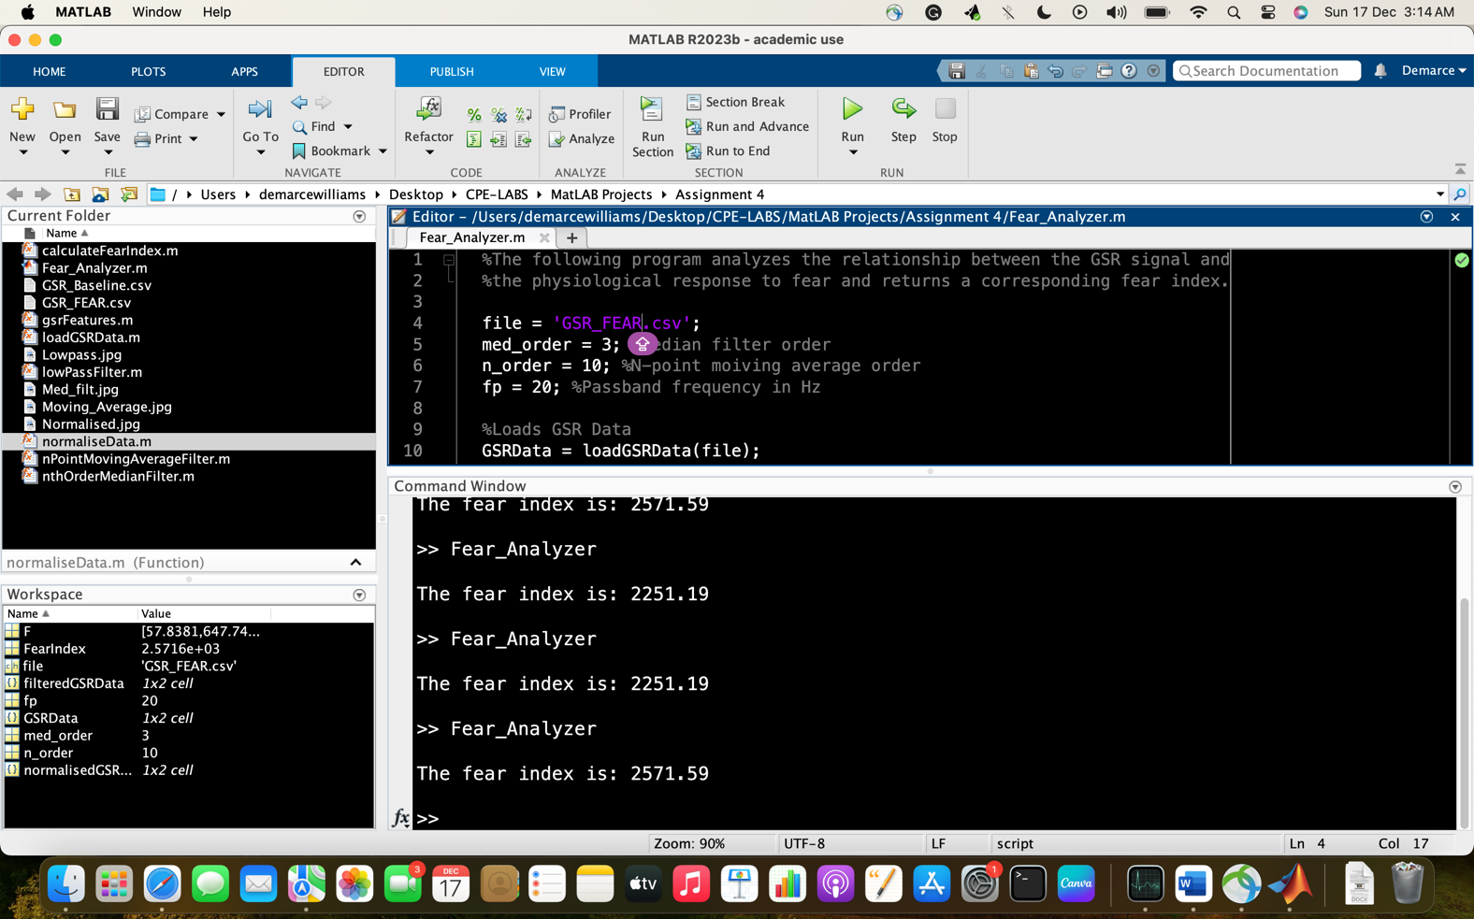

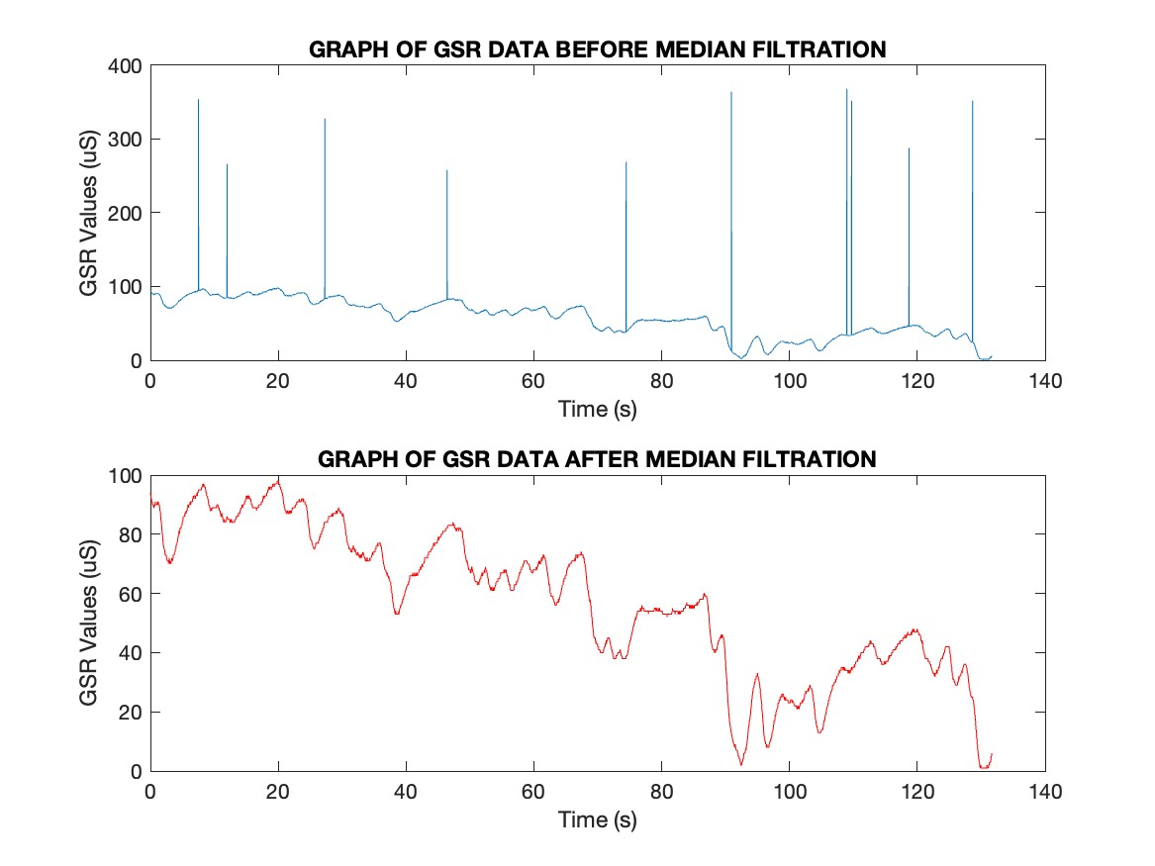
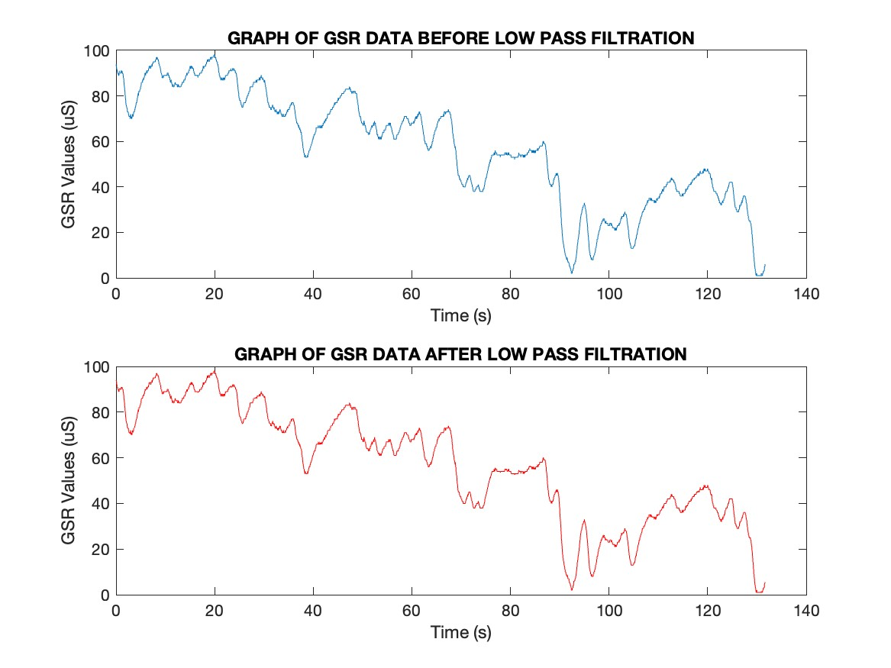
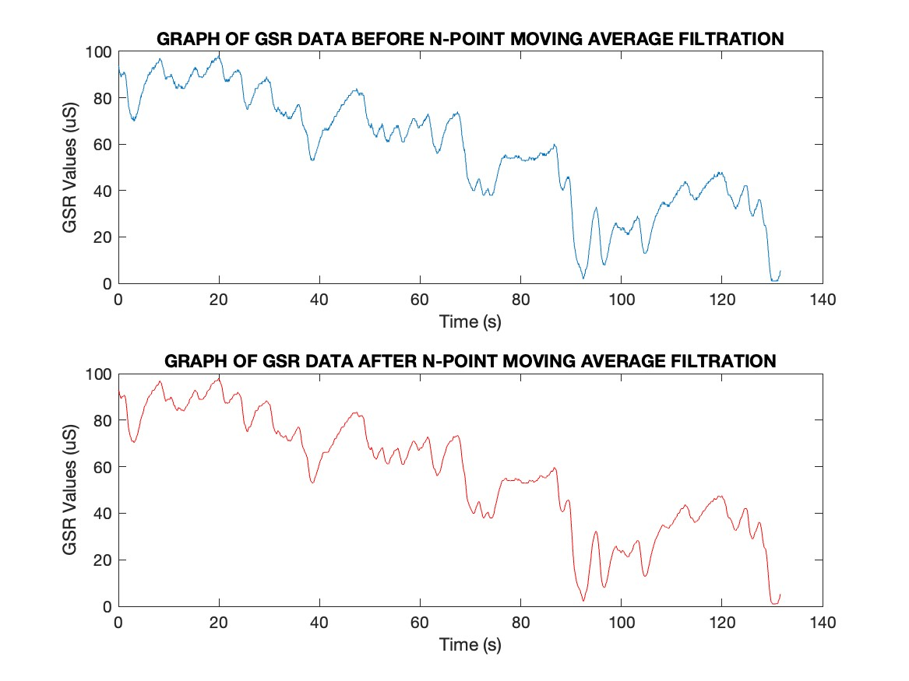
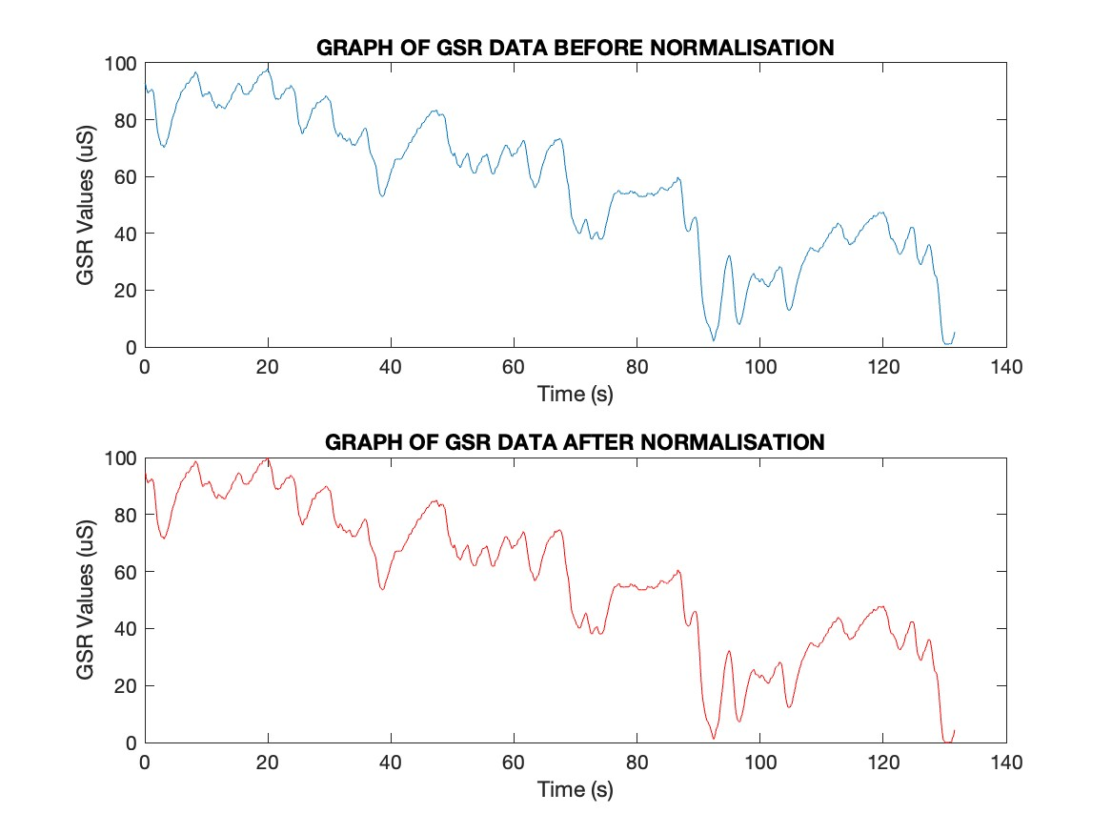
, which are in agreement with the expected test case.

Test case 2: GSR_Baseline.csv

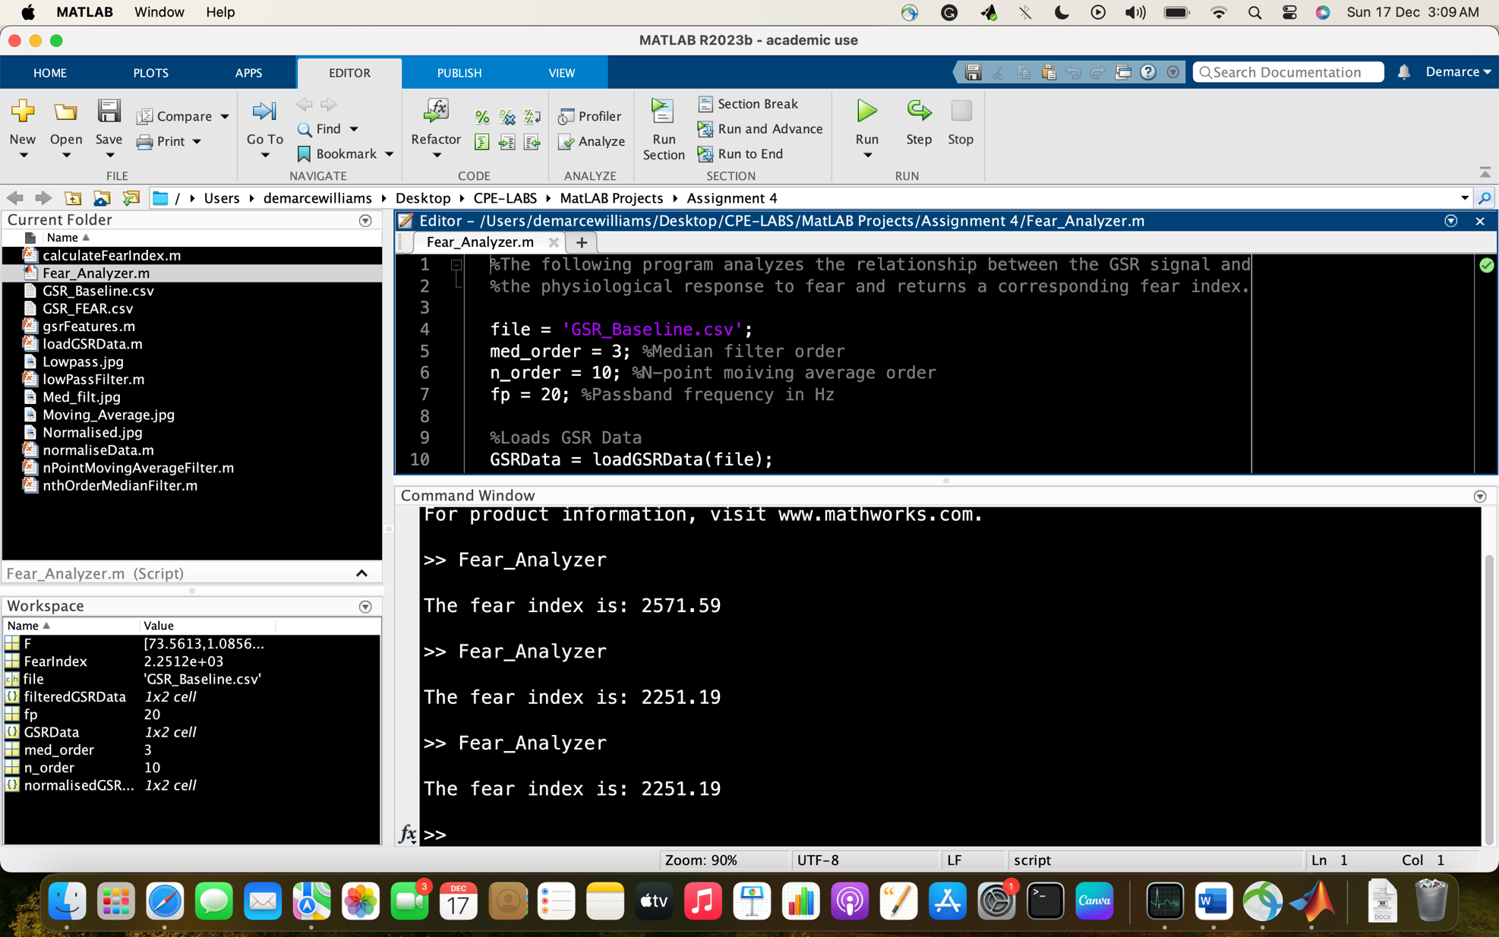

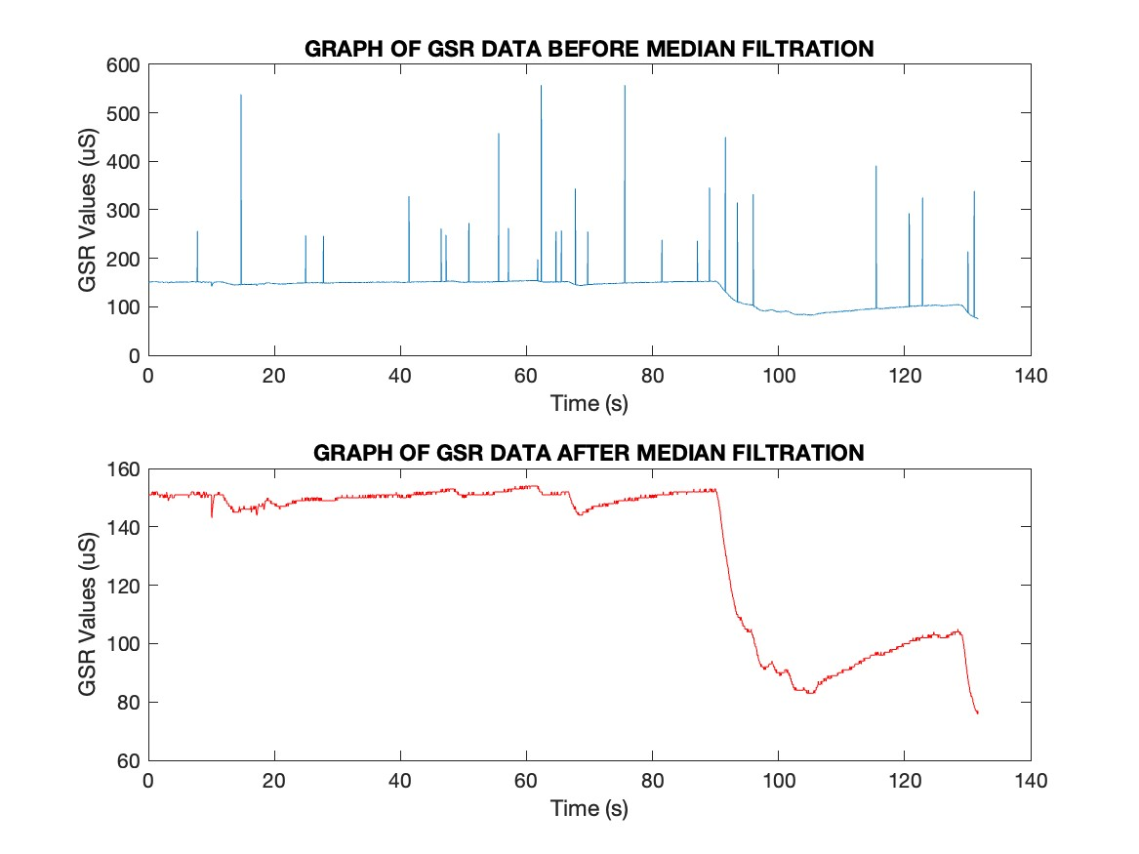
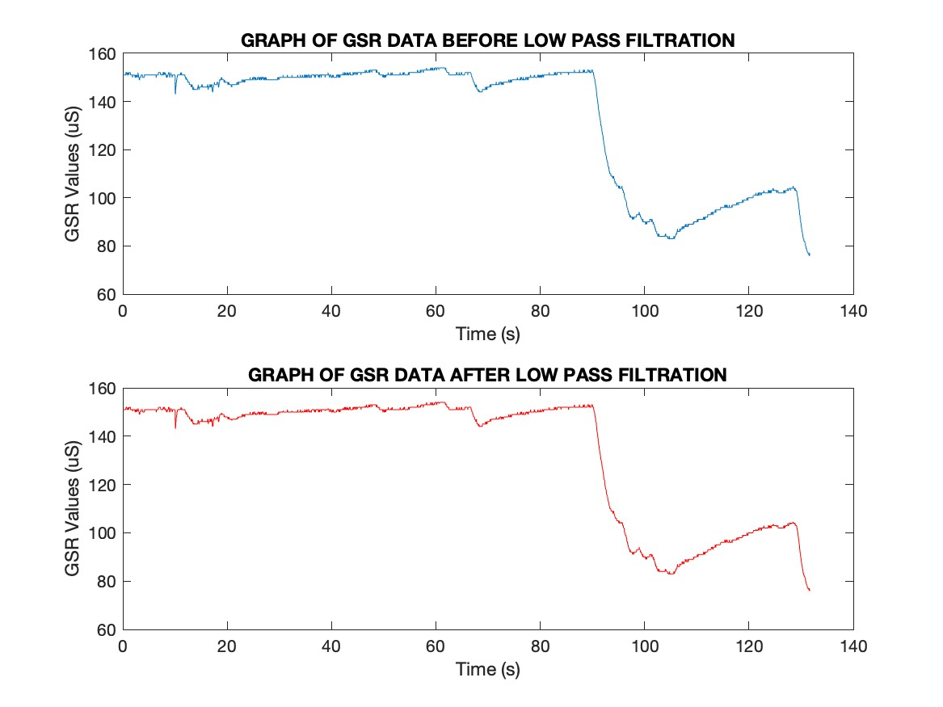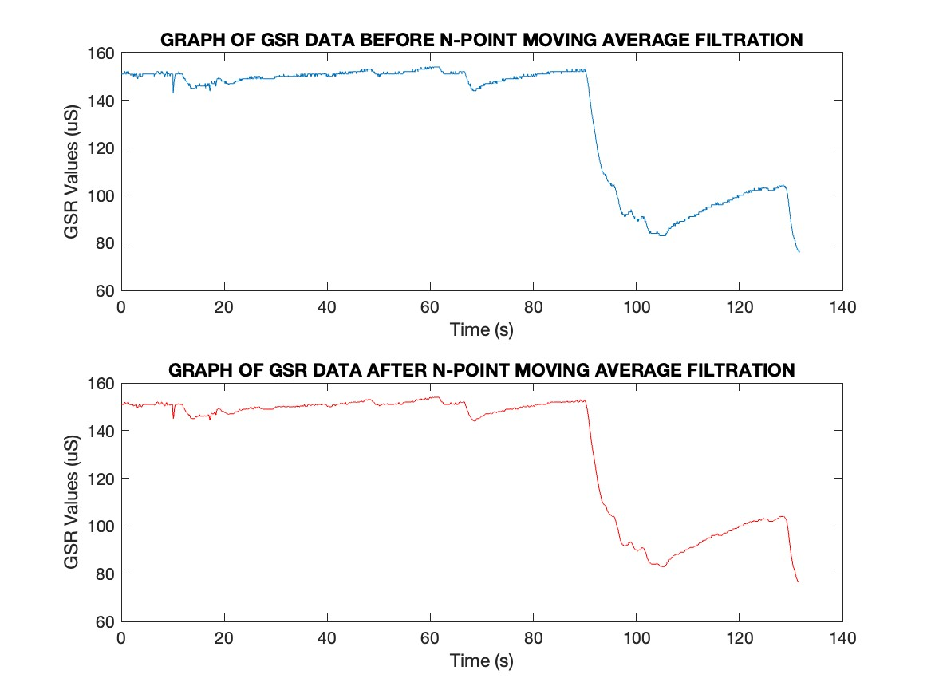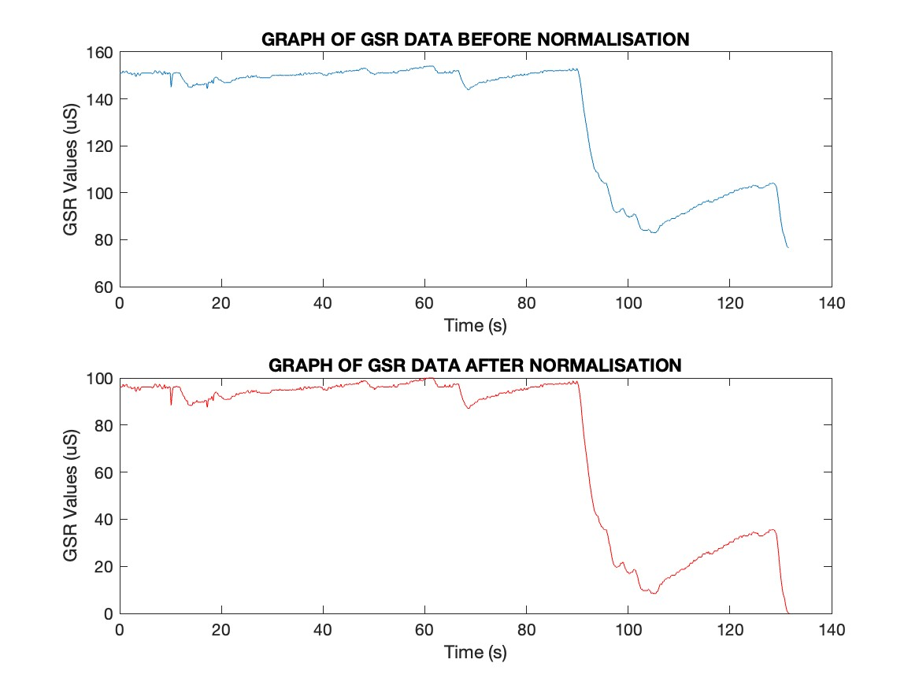
, which are in agreement with the expected test case.

The User’s Guide
- To execute the program, compile and run the code found in the file named Fear_Analyser.m.
- The user may change function parameters( like file name) by modifying the values of the variables found in the main MATLAB file (Fear_Analyser.m).
- He user may also change the median filter or moving-point average order, or the passband frequency if they wish.
- User may have to re-run the program each time they wish to analyse a new file.

